THE WINDSOR CONFERENCES ON COMFORT: THE PEOPLE
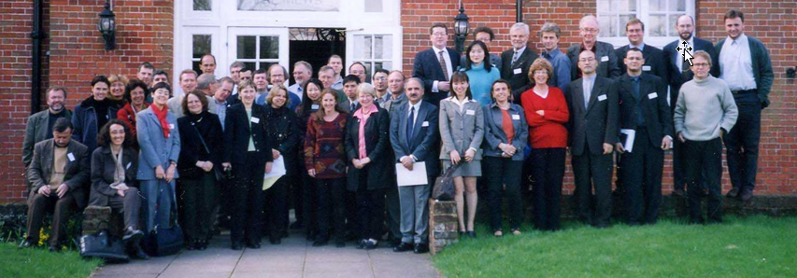
2nd Windsor Conference – 2001
8th Windsor Conference – 2014
10th Windsor Conference – 2018
11th Windsor Conference - 2020

